**STORED PROCEDURE**

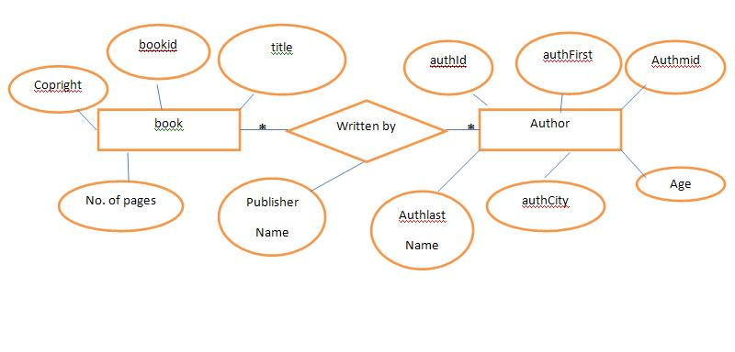

**CREATION OF TABLES:**

1)create table book135

( bookid int primary key,

title varchar(20),

pages varchar(20),

copyright varchar(20)

);

2)create table author135

( authfirst varchar(20),

authmid varchar(20),

authlast varchar(20),

authid int primary key,

authcity varchar(20),

authage int

);

3)create table writtenby135(

pubname varchar(20),

bookid int,

authid int,

foreign key (bookid) references

book135(bookid) on delete cascade

on update cascade,

foreign key (authid) references

author135(authid) on update cascade

on delete cascade,

primary key(bookid,authid)

);

1. **Get the title,author name,publisher name for author whose city contain total no of a=2?**

select b.title,a.authfirst,a.authmid,a.authlast,w.pubname,a.authcity from book135 as b,author135 as a,writtenby135 as w where b.bookid=w.bookid AND a.authid=w.authid AND a.authcity like '%a%a%';

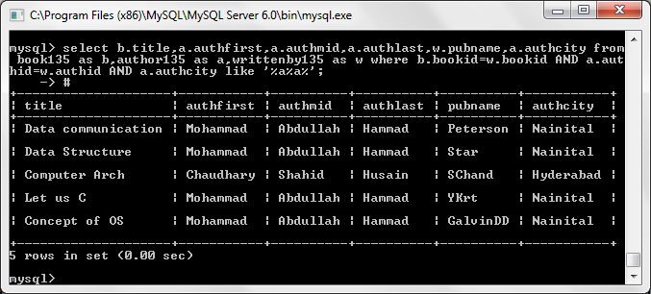

1. **Give the details of the book which is written by at least two authors.**

select b.* from book135 as b,author135 as a,writtenby135 as w where b.bookid=w.bookid AND a.authid=w.authid group by w.bookid Having count(w.authid)>1;

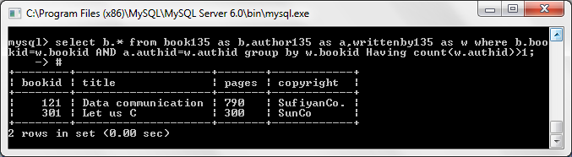

3) Write a stored procedure (SP Name : **insertIntoAuth**) to insert the Author information.

CREATE PROCEDURE insertIntoAuthor( _authfirst varchar(20), _authmid varchar(20), _authlast varchar(20), _authid INT, _authcity varchar(20), _authage INT)

BEGIN

INSERT INTO author135(authfirst,authmid,authlast,authid,authcity,authage)

VALUES(_authfirst,_authmid,_authlast,_authid,_authcity,_authage);

END

CALL insertIntoAuthor('Ramesh','S','Gaonkar',05,'New York',54);

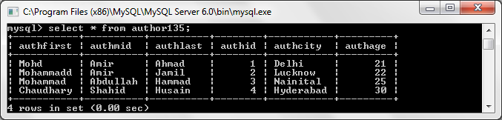

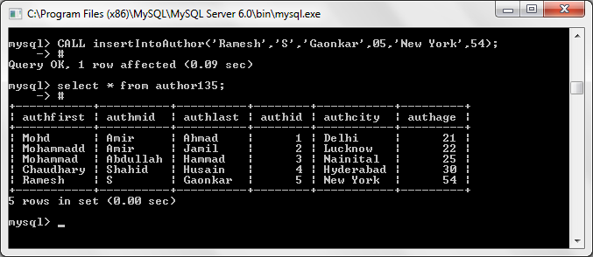

**4)Write a stored procedure (SP Name : insertBookInfo) to insert the book information such as bookid, title, no. of pages, copyright, authorId, Publisher Name. (Use two stored procedure and call it from one stored procedure i.e nested SP). (SP Name : insertBook, insertWBy).**

CREATE PROCEDURE insertbookInfo35( _bookid int,_title varchar(20),_pages varchar(20),_copyright varchar(20),_authid int, _pubname varchar(20))

BEGIN

DECLARE aid int;

DECLARE pn varchar(20);

CALL insertWBy(_authid, _pubname, aid, pn);

INSERT INTO book135(bookid,title,pages,copyright) VALUES (_bookid,_title,_pages,_copyright);

INSERT INTO writtenby135(pubname,bookid,authid) VALUES (pn,_bookid,aid);

END

CREATE PROCEDURE insertWBy35(IN aid int,IN pn varchar(20),OUT a_id int,OUT p_n varchar(20))

BEGIN

set a_id=aid;

set p_n=pn;

END

call insertbookInfo35(993,'Sports','200','Sports Today',9,'CricInfo')#

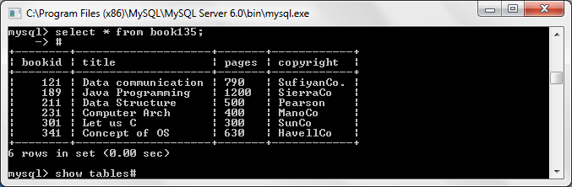

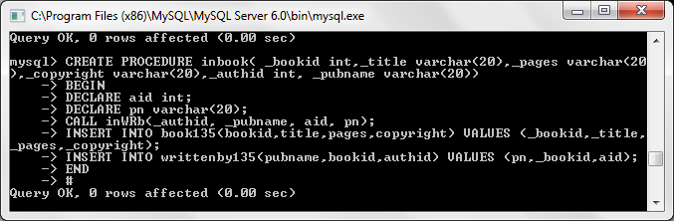

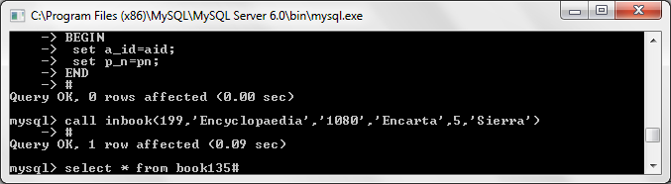

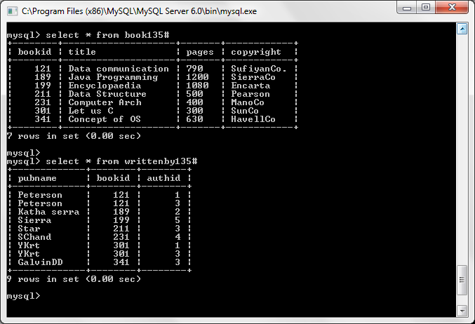

**5) Write a stored procedure to delete the Author information using its AuthID. (Notr: If Author book(in Book Table) exists for AuthID, then it should display message as ‘You can’t delete Author because total ‘no‘ book exist in ‘BookTable‘. First delete all the books written by him‘).**

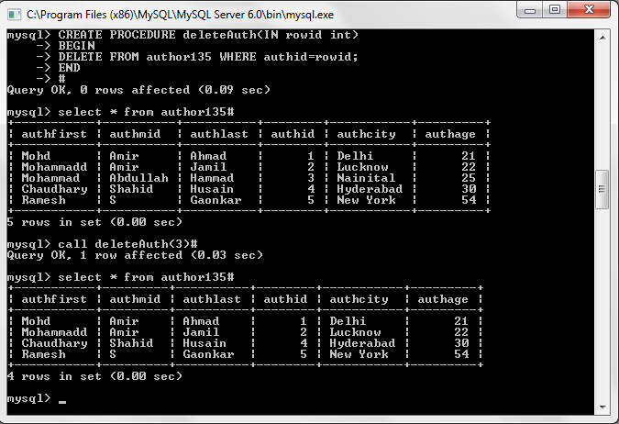

**6) Write a stored procedure to delete the Book using AuthID. (Note: Book information should be deleted from both Book and Book_writtenBy_Author table).**